Hello, friends:

I am using Zoom as the primary tool to teach online piano lessons. Here is a quick glance at some key things that I believe are worthy of addressing to make ensure this you are having as high quality an experience as possible.

ITEMS TO ADDRESS BEFORE OUR ZOOM SESSION

1. determine which instrument is best:
You may only have one option - this is fine! If you have the choice of either a piano or a keyboard, the keyboard may be better than an acoustic piano since the volume can be controlled more drastically.

2. determine which space is best:
If it is possible, try to dedicate some quiet space and quiet time for our lessons. I know that many families have siblings, moms and dads, dogs, cats, home offices, and all kinds of gadgets that make sounds (washing machines, dishwashers, vacuum cleaners, etc.). Often, the built-in microphones on phones, tablets, and computers can be super-sensitive. So, if at all possible, find a room in which you can close the door and ask your family to kindly keep the volume to a minimum. Aim to have a well-lit area, but please avoid having a window or light in the same path of the camera on your device (laptop, phone, ipad). Do a quick Google search on “lighting for Zoom” (or similar) and you will find countless articles, videos, and tips.

3. determine which device is best:
If you have some options, think about the option that is going to be best for you. Laptop? Tablet? Phone? Consider your screen size; this may be a factor when it comes to your ability to see my keyboard. Also, the sound you hear may be a factor, too. Some of my students prefer to use Bluetooth headphones or powered speakers. For the sound I hear, some folks use external microphones and some have an interface. My advice is to start with what you have and to build from there only if you feel it is necessary. Whatever device you use, be sure to charge it in advance so you can start with a full battery.

4. placement of your device in proximity to the piano/keyboard:
Where you place your device will have a direct impact on how effective I can be as a teacher. If I cannot see your hands, it is difficult for me to comment on fingerings or hand placement. Some of my students use a second web camera for a “top / keyboard view”. Others put their device on a stand or tripod so I can see them and the complete keyboard, too. It’s really in your best interest to take a little time and explore the best setup possible given what you have at home. Also, if you are using the built-in microphone on your device, the distance from the keyboard or piano can make a real difference!

...here is an example of a tripod-style stand for your iPad or phone...

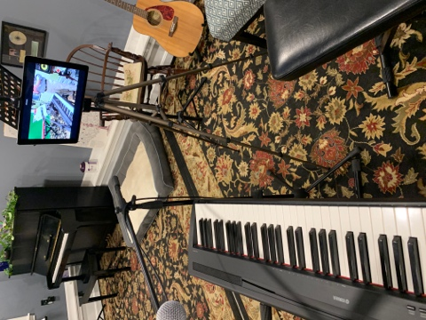

...notice in this example (the screen on a tablet) that the area is well-lit and the keyboard is clear.

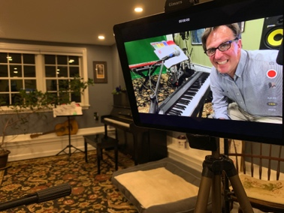

5. get the Zoom app:

for a computer: https://zoom.us/download...be sure to choose the TOP option, "Zoom client for meetings":

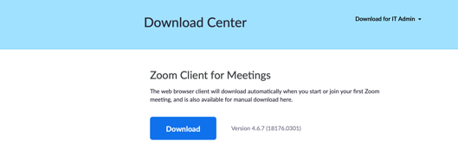
For mobile devices (phones/tablets), go to the App Store or Google Play and select the Zoom Cloud Meetings app. After downloading this free app, the icon will look like this:
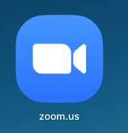
6. what you will experience from me:
I've been working on my end to achieve high quality video and audio. Here are a couple of things about what you can expect:

MY VIDEO: On your screen, it will look something like this:

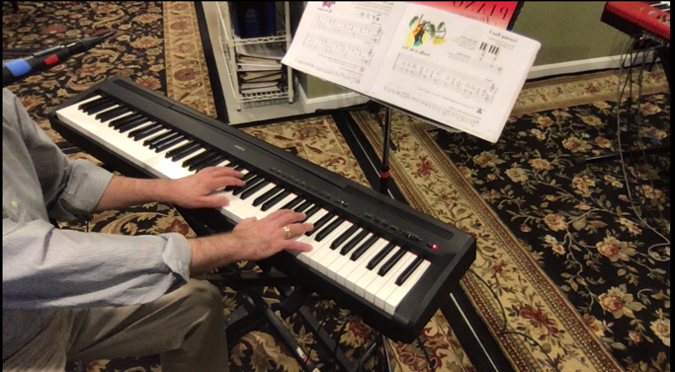

My laptop is on a swivel-stand, so I can easily move my computer camera so you have a closer view of my hands. Also, I can easily swivel the stand so we can have a “face-to-face” at any time during the lesson.

MY AUDIO:
I am using a keyboard and lav/clip-on microphone that feed directly into a mixer, then into a sound interface, and finally into a MacBook Pro. I hope that the combination of all of these things gives you a sound that is high quality and consistent. Please remember that your internet speed and service (and how much it is being taxed at the same time as our lesson) may have a direct impact on the quality of your experience.

OTHER THINGS TO KEEP IN MIND

- Headphones:
I have heard from students that when they use headphones (like over-ear, blue tooth headphones) the sound is best. When doing so, if you have difficulty hearing yourself, try the "one on, one off" method (one headphone on your ear, the other not on your ear). You are fine to use the speakers on your phone/tablet/computer but, in general, I think that the ability to hear low frequencies is much better with headphones…even earbuds can make a difference.

- Internet speed:
The speed of your internet (service plan, router, etc) can be a significant factor and determine the quality of your experience. Also, the amount of internet traffic at any one time can also be a contributing factor.

(more…)
Here is a simple test that I used:

https://www.measurementlab.net

…and the result that came back looked like this:

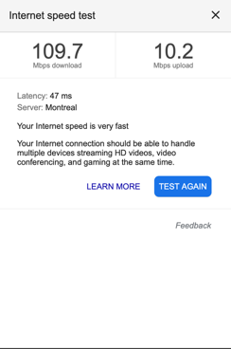

In general, the higher the number, the more “mega bits per second” can flow in and out and, as a result, a better overall experience will be achieved. Another contributing factor to slowness or overall clarity is how many people at your house are in meetings, gaming, or using other data-intensive things at the same time as your lesson; minimize other non-essential meetings if at all possible. Be sure to check that these things are not inadvertently running in the background.

- Just before your lesson time…
On the day of your lesson, I send a reminder email first thing in the morning. At least 10-minutes before your scheduled lesson time on that day (possibly up to three hours before), I will send the Zoom invite via email. Please click on the link two or three minutes before your lesson start time and you will be in the “waiting room”; I will admit you punctually at the deignated time of your lesson. If you or I are having technical issues, we should use phone/text to remedy. You are welcome to call/text me if you are having difficulty (207) 408-1173. Here is a sample of what the Zoom invite may look like:

